Buying & Rental Reservation system
Aim: To Develop a Buying & Rental Reservation system by using Zoho CRM
https://creatorapp.zoho.in/https://github.com/raghu337/Cloud-computing-CSA1527

Procedure:
● Define three user roles: Owner, Tenant, and Admin.
● Create separate pages for Property Owners, Tenants, and Admin staff.
● Assign permissions to each role using Zoho IAM.
● Allow Owners to add, view, and update their property details.
● Allow Tenants to search properties and make rental bookings.
● Allow Admin to manage all users, properties, and rental records.
● Check that each role can access only its own dashboard and pages.

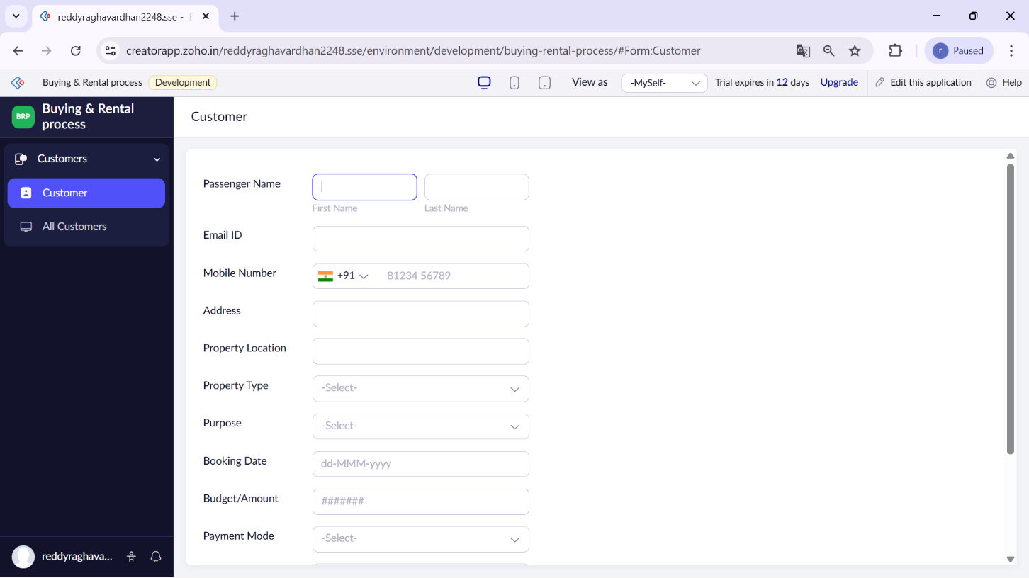

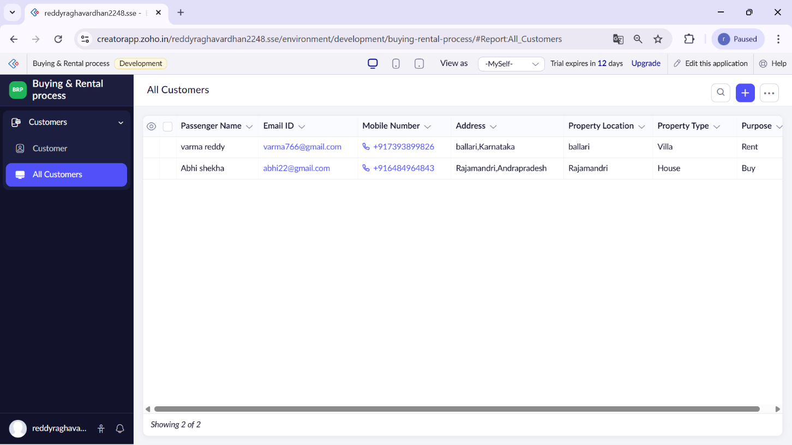

Result:
A simple cloud-based Rental Reservation System was successfully developed and deployed using Zoho Creator. The application allowed owners to manage property details, tenants to search and book rental properties, and admins to control overall system operations.

